**LAB DAY-2**

**Execrise-6:**

**Program:(Dividion)**

num1=as.integer(readline(prompt = "Enter the number 1:"))

num2 =as.integer(readline(prompt = "Enter a number2:"))

div=num1/num2

print((paste("Division:",div)))

**Output:**

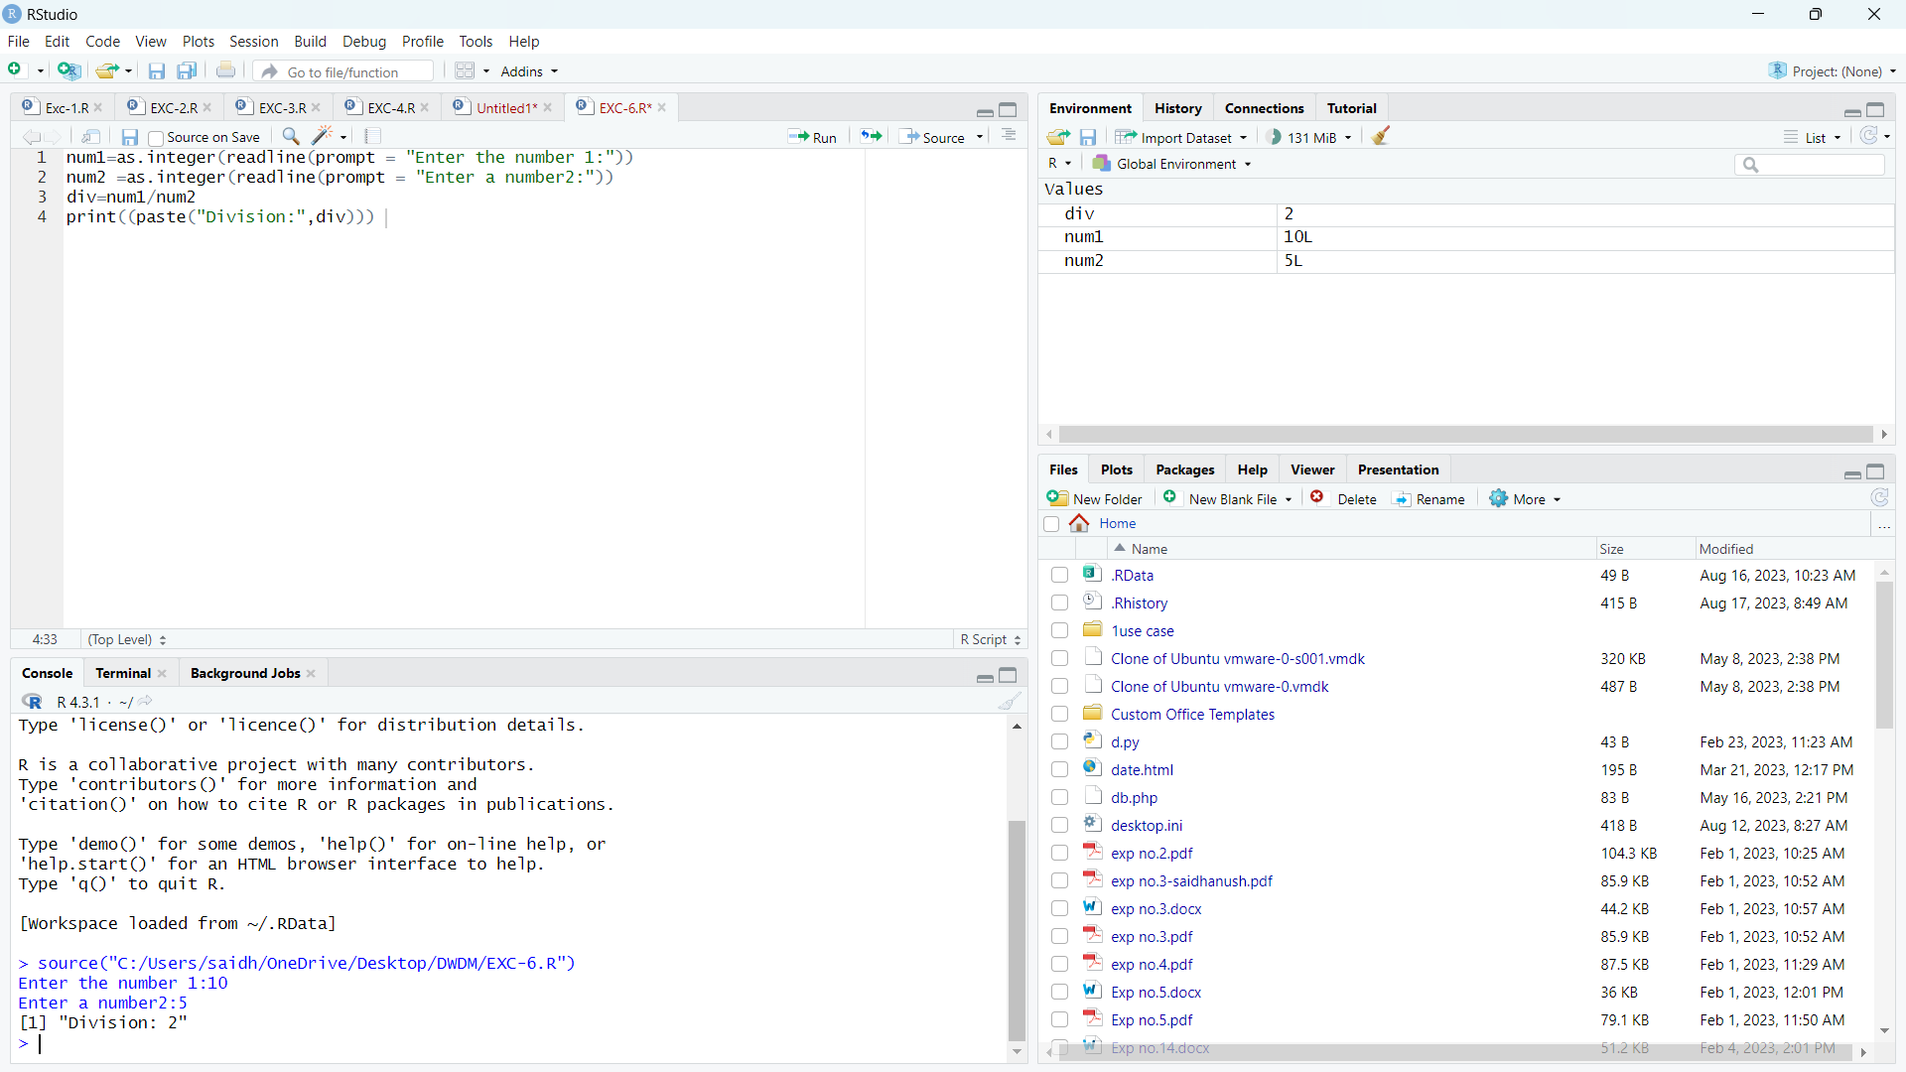

**Execrise-7:**

**Program:(Histogram)**

temperatures <- c(20, 22, 25, 29, 23, 27, 28)

result <- hist(temperatures,

main = "Maximum Temperatures in a Week",

xlab = "Degree Celsius",

ylab = "Day",

names.arg = c("Sun", "Mon", "Tue", "Wed", "Thu", "Fri", "Sat"),

col="green"

)

Print(result)

**Output:**

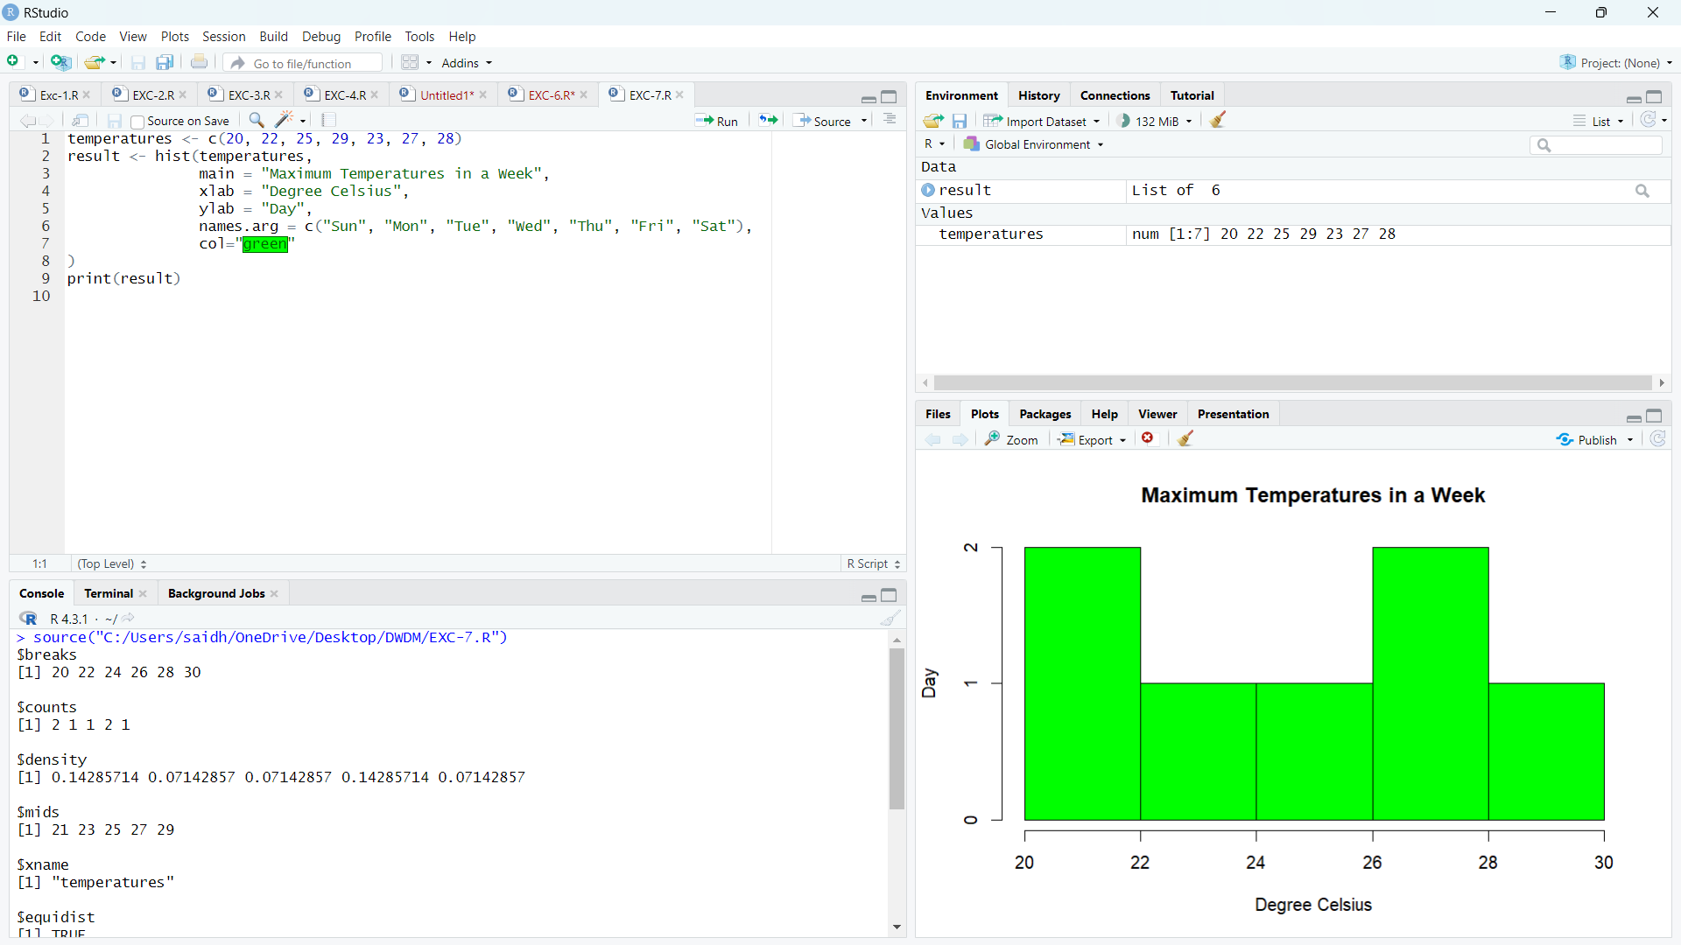

**Execrise-8:**

**Program:(Linear regression)**

x <-c(150,174, 138, 186, 128, 136, 171, 163, 152, 131)

y<-c(63, 81, 56, 91, 47, 57, 76, 72, 62, 48)

relaƟon <-lm(y~x)

print(summary(relaƟon))

a <-data.frame(x=170)

result <- predict(relaƟon,a)

print(result)

png(file = "linear_regression.png")

plot(y,x,col = "red",main = "Height and Weight Regression",abline(lm(x~y)),cex = 1.3,pch = 16,xlab = "Weight in Kg",ylab = "Height in cm")

dev.off()

**Output:**

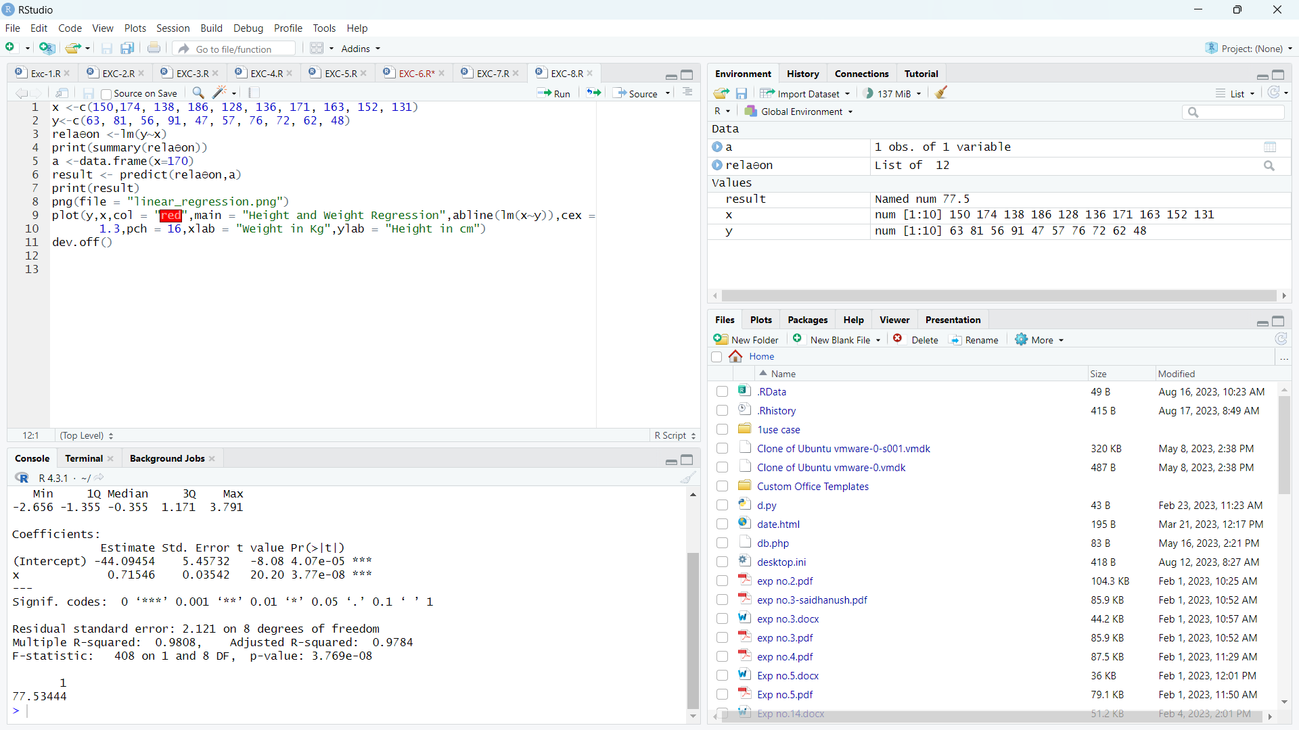

**Execrise-9:**

**Program:(Median)**

height <-c(150,174, 138, 186, 128, 136, 171, 163, 152, 131)

result.median <-median(height)

print(result.median)

**Output:**

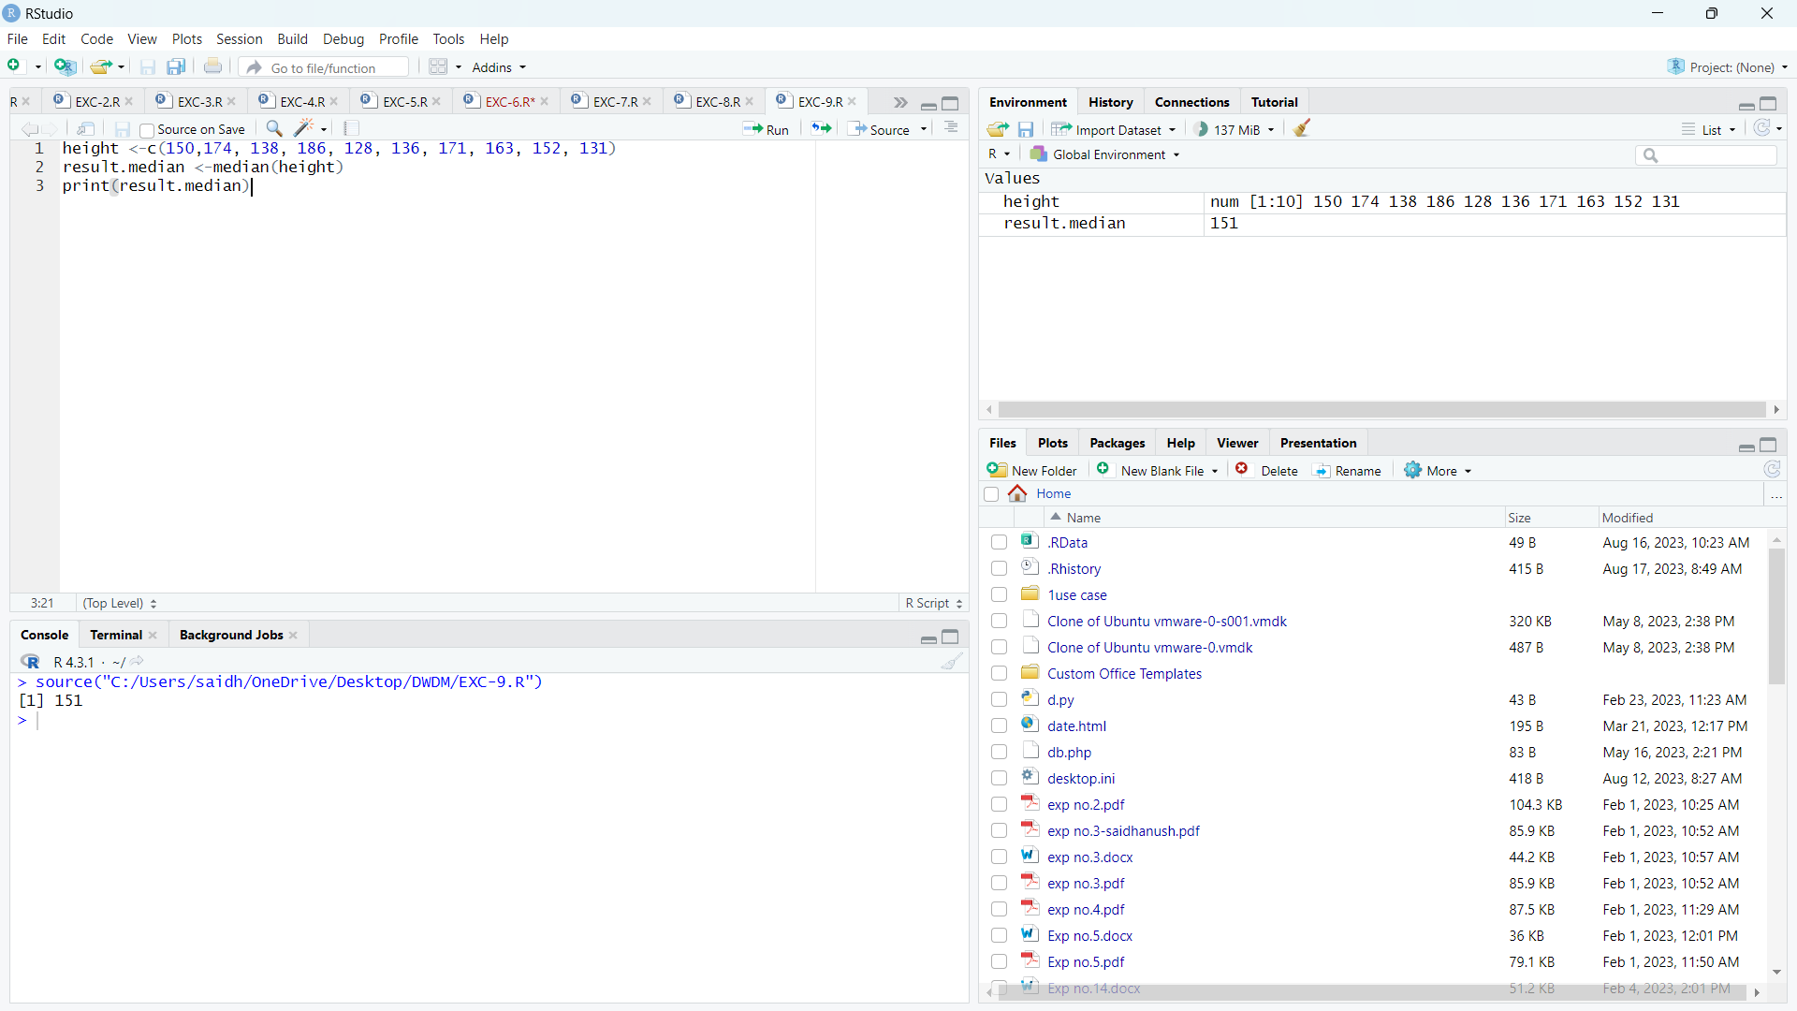

**Execrise-10:**

**Program:(Min max normalization)**

original_vector <- c(10, 20, 30, 40, 50)

normalized_vector<-(original_vector- min(original_vector)) / (max(original_vector) - min(original_vector))

print(normalized_vector)

original_vector <- c(100, 200, 309, 40, 50,60,70,80,90,10)

normalized_vector<-(original_vector- min(original_vector)) / (max(original_vector) - min(original_vector))

print(normalized_vector)

**Output:**

